# Objective

This example project demonstrates how to create a Real Time Clock (RTC) using configurable watchdog timers of PSoC 4 BLE device. The initial time for RTC is set by reading the time from a BLE time server (iOS device for example) using BLE Current Time Service (CTS).

|  |
| --- |
|  |

# Overview

PSoC 4 BLE and PRoC BLE devices have a watchdog timer that is driven by low frequency (LF) clock of the device. The source of the LF clock can either be:

1. Inaccurate internal Low Speed Oscillator (ILO)
2. Accurate Watch Crystal Oscillator (WCO)

WCO is required for low power mode of operation of the BLE interface and most of the BLE end applications will use a WCO in their design. The accuracy of the WCO in a typical BLE design is <70ppm across PVT when using a 10ppm accurate external crystal.

This highly accurate WCO can be used in conjunction with watchdog times of PSoC 4 BLE device to provide a 1 second pulse interrupt that can drive a firmware RTC module. This example project demonstrates how to instantiate an RTC in PSoC 4 BLE device using a combination of WCO, watchdog counter and firmware RTC components. See PSoC 4 BLE device [technical reference manual](http://www.cypress.com/?rID=99430) for more details on WCO and watchdog timers.

BLE also provides Current Time Service (CTS) that lets a GATT time client to get the current timing information from a GATT time server. The BLE CTS server is in-built in iOS and all the iOS devices allow a BLE GATT time client to connect to them and extract the timing information. This example project utilizes this feature of iOS devices and instantiates a CTS GATT client that initially fetches the current time value on establishing a BLE connection with an iOS device and the RTC is initialized with this timing information.

The functional block diagram of this example is as shown in .

Figure : PSoC 4 BLE RTC Example Block Diagram

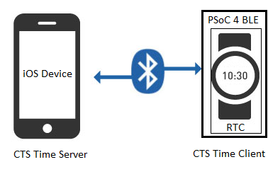

# Requirements

**Design Tool:** [PSoC Creator 3.1](http://www.cypress.com/PSoCCreator/) SP1 with built-in GCC 4.8.4

**Associated Devices:** All PSoC 4 BLE & PRoC BLE devices

**Required Hardware:** [CY8CKIT-042-BLE Bluetooth® Low Energy (BLE) Pioneer Kit](http://www.cypress.com/cy8ckit-042-ble/)

# Hardware Setup

The BLE Pioneer Kit has all the necessary hardware required for this example. shows the hardware setup for this example. USB connection is required for programming the BLE Pioneer Kit and also to display user messages and RTC timing information on host PC’s serial port terminal program.

Figure : Kit Setup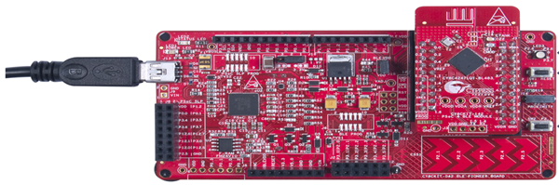

# PSoC Creator Schematic

Figure 3. PSoC Creator Schematic



**Firmware**

Figure . BLE RTC Example Project Source Files

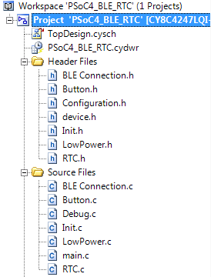

RTC 1 second interrupt and firmware block source code

Printf to UART interface hander function source code

System initialization source code

PSoC 4 BLE device low power mode configuration source code

Main entry point source code for the example project

User button interface routine source code

BLE event handler, connection manager and service discovery source code

The firmware source files for this example project and a short description of each of the source files is shown in . The firmware is modular and provides multiple configuration flags to test and debug different RTC modes of operation. All the firmware configuration flags are located in Configuration.h file and a short description of each of the configuration flags are shown in .

Figure . BLE RTC Firmware Configuration Flags

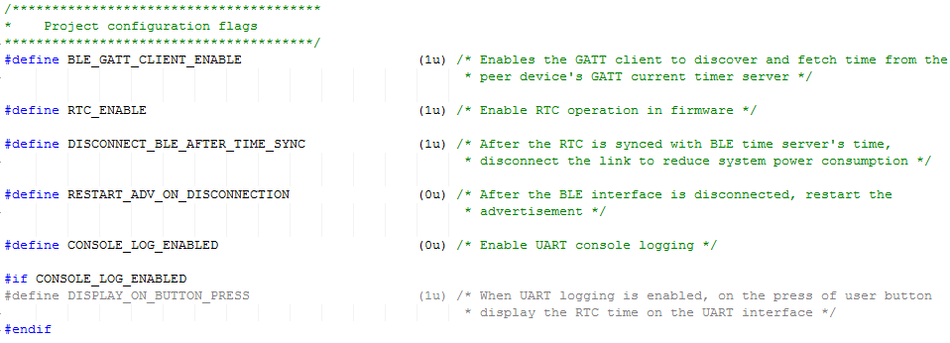

**Test Setup**

* Enable required firmware configuration flags in Configuration.h file
* Build this example project in PSoC Creator 3.1 SP1 or later
* Program the hex file generated onto BLE-Pioneer kit Baseboard.

**Test Procedure**

* Connect the BLE-Pioneer Kit Baseboard to Windows host machine using the USB cable
* Open a terminal emulator such as Putty or Tera Term for the BLE-Pioneer Kit. The COM settings are: Baud rate – 115200 bps, Data bits – 8, Stop bits – 1, Parity – None.
* Reset the device (by pressing the Reset switch SW1 on BLE-Pioneer Kit Baseboard) to see the output shown in on the terminal. The device is advertising at this point and waiting to be connected with an iOS device.

Figure . BLE RTC Firmware Startup

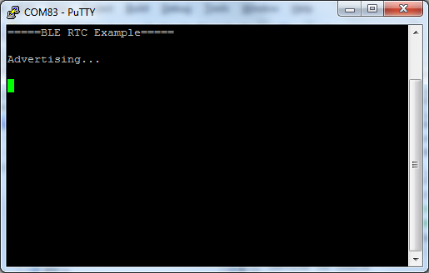

* For this example, we are using an iPhone 5C. On the iPhone, navigate to the phone Settings, enable Bluetooth. The BLE Pioneer Kit is listed as one of the devices nearby. Touch it to connect. See .

Figure . iPhone Settings and RTC Device Listing

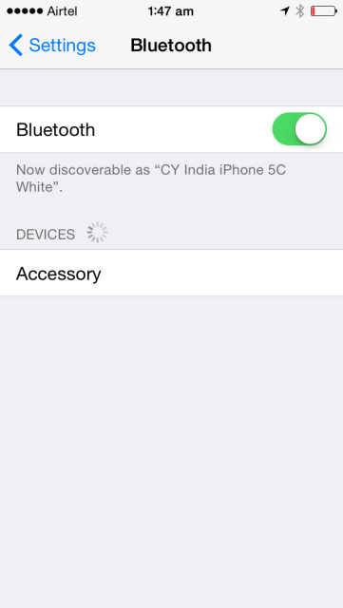 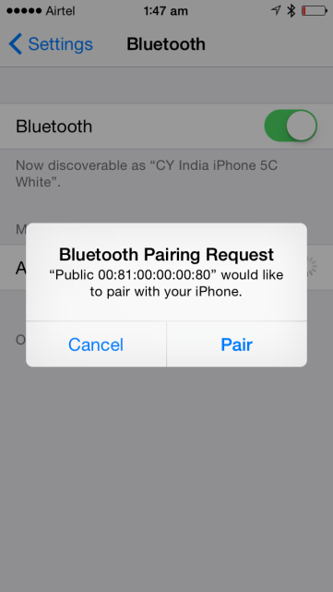

* Once connected, RTC on PSoC 4 BLE device is started with the time synced from the peer iOS device (iPhone in this case) and disconnects the BLE link automatically as shown in .

Figure . PSoC 4 BLE Connection, RTC Time Sync & Disconnection

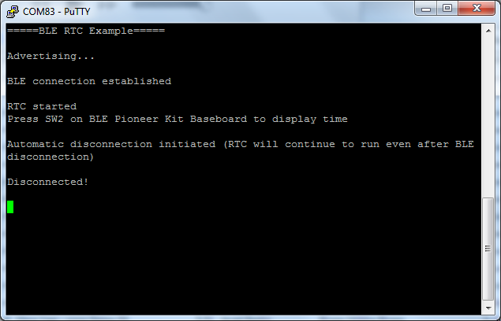

* Now press SW2 on BLE-Pioneer Kit Baseboard to display the current time of the RTC as shown in .

Figure . PSoC 4 BLE RTC Time Display

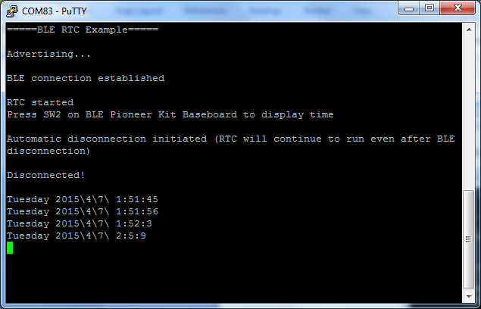

# RTC Accuracy & Power Consumption

The accuracy of RTC is dependent on the WCO clock variation resulting from inherent crystal frequency stability, PSoC 4 BLE WCO oscillator block specification and WCO load capacitance tuning. On a bench level testing using BLE-Pioneer Kit, the accuracy of the RTC was found to be 58ppm (5 seconds offset per day). When the BLE interface is completely shut down and only RTC is active in the design, then PSoC 4 BLE device consumes an average current of <1.8uA.

# Related Documents

lists all relevant application notes, code examples, knowledge base articles, device datasheets, and Component datasheets.

Table 1. Related Documents

| Document | Title | Comment |
| --- | --- | --- |
| [AN91267](http://www.cypress.com/go/AN91267/) | Getting Started with PSoC 4 BLE | Provides an introduction to PSoC 4 BLE device that integrates a Bluetooth Low Energy radio system along with programmable analog and digital resources. |
| [PSoC 4 BLE TRM](http://www.cypress.com/?rID=99430) | PSoC 4 BLE device TRM | A detailed description of all the features and internal architecture of PSoC 4 BLE device. |